IBM has provided a solution. There is a debugging flag that can be enabled which causes a different version of the JavaScript libraries to be used. That alternate version is not minified and hence does not show compressed in the debuggers.
Here is the recipe to enable the debugging:
1. Open up the WAS admin console.
2. Expand Resources > Resource Environment > Resource Environment Providers
IBM提供了一个解决方案。有一个启用调试标记,可以导致一个不同版本的JavaScript库。替代版本不是缩小,因此不显示压缩的调试器。
这是启用调试配方:
1. 打开管理控制台。
2. 扩大资源>资源环境>资源环境提供程序
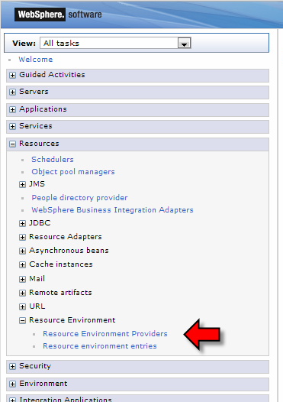
- Select the provider called "Mashups_ConfigService"
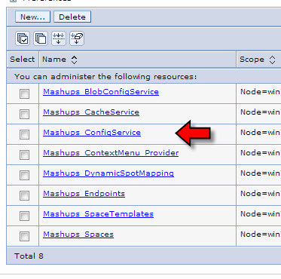
- Select Custom Properties
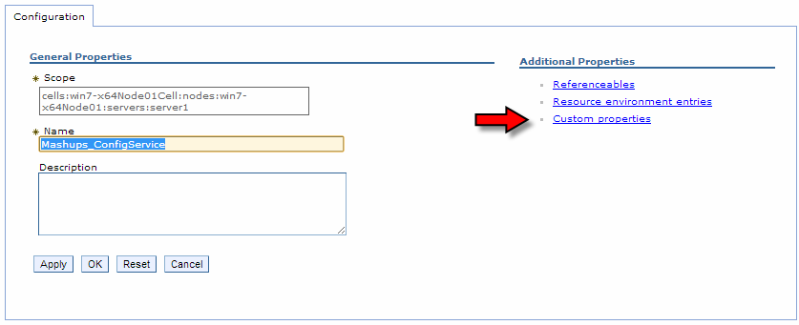
- Select the "isDebug" property. The easiest way to find this is to use the filter
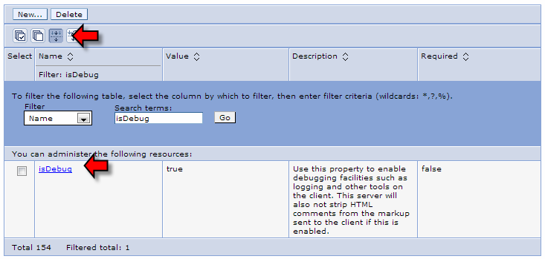
- Change the value from false to true (or true to false to disable again) and click OK
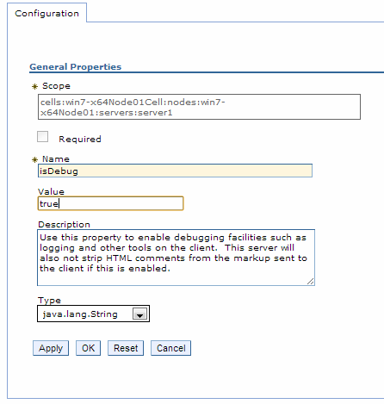
7. With the resource definition changed, save/commit the changes in the WAS admin console
and restart the WAS server. Your debug changes will not start happening until after a server
restart. Once the server has been restarted, code will now show up non-minified. Realize
that this may have an impact on overall performance but a small price to play during Coach
View debugging. If you are using a shared environment with other developers, be sensitive
to their needs as well as your own.
Coach View Construction Tips
DOM root access in a Coach View
It is common to include a "Custom HTML" entry in a Coach View so that content may be added to
it, a typical example might be:
<div class="MyClass">
</div>
Within the load() event, we would then create DOM content and add it into the DOM model.
To find the appropriate entry in the DOM tree, the following code fragment will work:
var myNode = query(".MyClass", this.context.element)[0];
Editing JavaScript for Coach Views
Unless the edits are small, it is not recommended to build the code of the callbacks for Coach Views
in the Process Designer editors. There is very little assistance here and mistakes can easily happen.
Instead, use a professional JavaScript editor with entry assist and copy/paste the code from the
editor into Process Designer. You will forget to perform this copy/paste a few times during
development but the trade between making that mistake and the errors you will introduce by not
using a proper JavaScript editor will more than compensate. I also recommend prefixing your
JavaScript code (in the editor) with some dummy definitions for the commonly used functions that
Page 371
will be used in your own code. This will provide the ability to have entry assist.
Adding a label
Many IBM supplied controls have a label associated with them. This label can be shown above the
new Coach View.
<div class="textLabel">
<label class="controlLabel"></label>
</div>
In the load code, we can set the text of the label with:
var labelDom = query("label", this.context.element)[0];
if (this.context.options._metadata.label != undefined &&
this.context.options._metadata.label.get("value") != "") {
labelDom.innerHTML = this.context.htmlEscape(this.context.options._metadata.label.get("value"));
}
In addition, we will want to handle the visibility settings of the label:
var labelDivDomNode = this.context.element.querySelector(".textLabel");
if (this.context.options._metadata.label == undefined ||
this.context.options._metadata.label.get("value") == "" ||
(this.context.options._metadata.labelVisibility != undefined &&
this.context.options._metadata.labelVisibility.get("value") == "HIDE")) {
// hide the label div
this.context.setDisplay(false, labelDivDomNode);
} else {
// show the label div
this.context.setDisplay(true, labelDivDomNode);
}
Working with visibility
The Coach View framework makes available a Visibility concept.
This is set on a Coach View by Coach View instance basis. The values are:
• Default (inherit from parent) – DEFAULT – Inherit the value from the parent coach view
• Required – REQUIRED – The Coach View is editable and MUST have a value
• Editable – EDITABLE – The Coach View is editable
• Read Only – READONLY – The Coach View is read only
• None (hide or disable) – NONE – The Coach View is hidden
It is up to each Coach View implementation to implement code to honor these settings. One way is
to create a handler function in the load:
this._handleVisibility = function() {
var visibility = "DEFAULT";
if (this.context.options._metadata.visibility != undefined) {
visibility = this.context.options._metadata.visibility.get("value");
}
if (visibility == "NONE") {
Page 372
this.context.setDisplay(false);
} else {
this.context.setDisplay(true);
}
}
Then we will call this handler in the view function and also when the _metadata.visibility property
changes as seen in the change function.
Using a Dijit Widget in a Coach View
When using a Dijit Widget in a Coach View, each widget is expected to have a unique "id" value.
Unfortunately, when we place a Coach View in a table, the same "context.viewid" is used for
each row in the column and hence the widget can end up with the same id which won't work.
Fortunately, Dojo provides an answer. The method
dijit.getUniqueId("<widgetType>")
will generate a unique id. The AMD object to load is:
dijit → dijit
Including a custom Dijit Widget in a Coach View
There are times when you might want to create your own custom Dijit Widget and use that when
creating a new coach view. Here is the recipe for achieving that. At a high level, the story
progresses by:
• Writing and testing our new Dijit Widget
• Packaging that widget in a ZIP file with a directory structure mapping to the module
• Adding the ZIP containing the Widget as a Web managed file
• Creating a "requires" JavaScript fragment mapping the module name to the ZIP file
• Adding the "requires" JavaScript fragment as a managed Web file
• Defining the "requires" JavaScript as an included JavaScript fragment
• Defining an AMD definition for our new widget
We will illustrate by example. Let us imagine that we are creating a new Widget called
"DateProgress" that exists in the module called:
kolban/widget/DateProgress
we will assume the following source level tree structure.
kolban
widget
DateProgress.js
templates
DateProgress.htm
We can export from an Eclipse based environment using the Export to File System:
Page 373
Page 374
We now zip this structure up
We add this zip (kolbanWidgets.zip) as a Web managed file to our BPM Process App.
Next we create a JavaScript file (AMDMap.js) that contains:
require({
packages:
[
{
name: "kolban",
location:
com_ibm_bpm_coach.getManagedAssetUrl('kolbanWidgets.zip',
com_ibm_bpm_coach.assetType_WEB, '<ToolkitAcronym>') + "/kolban"
}
]
});
This JavaScript source file then also gets added as a Web managed file. Now we have two
managed files. One is the ZIP that contains our Dijit widgets and the other is the JavaScript AMD
mapper. In the Coach View included scripts, we reference the AMDMap.js file:
Finally, we can now create a AMD dependency on our new module and map it to a variable.
Describing a Dojo based page declaratively
Within Dojo, we can describe the Dojo widgets to be used either programatically or declaratively.
Programatically means that we build the page layout within JavaScript by creating instances of
widgets and placing them at the appropriate DOM locations within the DOM tree. This gives us
optimal control over placement and parameters but has the significant down-side that we can't use
any visual editor to build them out. In addition, modification becomes complex as we have to
remember the layout at the program level. All in all, except for the simplest of pages, it is a slow
and cumbersome process.
The alternative is known as declarative layout. In this instance, we describe our screen through the
use of HTML which can be constructed in a suitable Dojo aware HTML editor such as Worklight
Studio or Maqetta. The HTML that describes the Coach View can then be placed in a Custom
Page 375
HTML component within the layout section of the Coach View definition. When the Coach View
is loaded, the HTML contained within that area is parsed looking for Dojo declarations. Those
Dojo declarations then cause the creation of the associated widgets. At the conclusion, we have a
Coach View which contains widgets and looks great.
The power of Coach Views is that they are not just static HTML but contain BPM data and respond
to events. We want to then augment the Coach View with JavaScript code that will handle
interactions with those widgets. When we created the widgets programatically, we had access to
the object that represented those widgets and could add handler and other logic. When we create
the description of the page declaratively, we need a little bit more work to get those widget object
references.
Dojo provides a class called "dijit/registry" which has a method upon it called
"byId(<name>)". This method returns a reference to the Dojo widget on the page that has the
corresponding id name. So for example, if we have a button on the Coach View that has an id of
"mySubmit", we can gain access to the Dojo widget corresponding to that button with:
var myButton = registry.byId("mySubmit");
There is one final snag with this though and that is the rule that each Widget on the page must have
a unique id value. Defining:
<div id="mySubmit"
data-dojo-type="dijit.form.Button"
data-dojo-props="label:'Submit'">
</div>
Has a problem. If we have two instances of the Coach View on the page then both buttons will be
given the same id and things will break. IBM BPM has a solution to this. If instead we code:
<div id="$$viewDOMID$$_mySubmit" data-dojo-type="dijit.form.Button"
data-dojo-props="label:'Submit'">
</div>
The special code of "$$viewDOMID$$" is replaced with the DOM ID of the Coach View itself.
So if we want to retrieve the button widget, we can now code:
var myButton = registry.byId(domAttr.get(this.context.element, "id") + "_mySubmit");
For any Dojo widgets used in a declarative style, always ensure that you have also used the AMD
loader to load the corresponding Dojo implementation of those widgets.
See also:
• Error: Reference source not found
Accessing images by CSS
It is not uncommon to use CSS to access an image. For example, instead of using the <img> tag to
show an image, one can use CSS to set the image in a <div>. For example:
.myClass {
width: 24px;
height: 24px;
background-image: url(A URL to an image);
}
will set the image. The "url" function in the CSS defines where the image is loaded. Unfortunately,
there appears to be a puzzle when we build Coach Views. What should the URL be to the image
file? We desire that the image be packaged with the Coach View so the first notion of adding the
image as a managed Web File seems like it might be sound … however there is a problem. The
URL to the image can only be determined programatically. It doesn't have a fixed value. With CSS
Page 376
styling, we don't have access to the JavaScript and hence can't dynamically define the location.
One solution to this puzzle is really quiet elegant. It works as follows:
1. Build the CSS you want to include in the Coach View. When you need reference to images,
supply the URL for those images as file names relative to where the CSS file can be found.
2. Place the images relative to the CSS file on the file system.
3. ZIP up the CSS file and the images maintaining the relative directory structure.
4. Add the resulting ZIP file as a managed web file.
5. Include the CSS file in the Coach View in the Coach View editor naming the ZIP file and
the CSS file contained within.
What happens is that when the CSS is loaded, its reference to the image files will be local to the ZIP
file and the server will satisfy those requests from the content of the ZIP.
If you need to update the CSS or image, you must repeat the process which includes packaging up
the file system into the ZIP and refreshing the managed web file that corresponds to that ZIP.
See also:
• Error: Reference source not found
Commonly used AMD loaders
When building Coach Views, there are AMD functions that simply keep coming up over and over.
Here we capture a cheat sheet for some of the most common:
AMD Alias Example Functions
dojo/query query query
dojo/_base/lang lang lang.hitch
dojo/dom-attr domAttr domAttr.get, domAttr.set
Sample Coach Views
Sample Coach View – trivial "hello world"
We start by creating a new Coach View. I called this one "HelloWorld1".
I defined the new Coach View as having a tag of "Control":
Page 377
This causes the new Coach View to appear in the Controls section of the Coach Editor.
Next, I built an icon that was 16x16 pixels. I used GIMP to create it but you can find many free
icons on the Internet. I added this icon into the Files of my Process App as a Web managed file.
By doing this, when the new Coach View appears in a Coach editor, it will have that icon in the
palette of available Coach Views. Looking ahead, it will look like:
Next an image was defined for the layout in the Coach Designer editor:
By defining an image here as the layout image, when the Coach Editor is shown, an appropriate
Page 378
place holder will be seen in the editor canvas area when an instance of the Coach View is added to
the canvas.
In the Layout tab, a CustomHTML component was added.
In the HTML properties, a small fragment of HTML was added to provide some visualization.
When I now create a Coach and add the Hello World Coach View component into the body of the
coach and have the Coach display, we end up with an HTML output as desired/expected.

